Louis Vuitton Leather Goods
MKT 3605 CMWA
19 November 2023
Audrey Prater

Executive Summary:

Louis Vuitton is a world-renowned brand with extensive target markets. Their ability to satisfy many demands with their leather goods has kept them in business since 1854. With four strategically selected target markets, some containing subsegments, we hope to offer some recommendations for Louis Vuitton to cater to more demands while remaining true to their brand and business model. Six gaps were strategically prioritized with three simple recommendations, with the reasonings given in this report. The impact of these target markets and their gaps on the market is heavily evident, and Louis Vuitton has the opportunity to communicate with them on a more personal, profitable level by understanding their consumers and addressing their needs.

Table of Contents
- Executive Summary...........................................................................................................1
- Focus....................................................................................................................................3
- Target Markets ...............................................................................................................3-6
- Value Proposition Per Target Market...........................................................................6-9
- 4 Ps Value Proposition..................................................................................................9-12
- Customer Roles and Behavior .................................................................................12-14
- Trends..........................................................................................................................14-15
- Gaps.............................................................................................................................15-18
- Prioritization....................................................................................................................18
- Recommendations.......................................................................................................18-20
- Appendix.....................................................................................................................20-22

- Focus
Leather goods and accessories made by Louis Vuitton, such as bags, belts, and boots, are the focus of this report. The majority of these leather goods fall under the following categories: textured leather, embossed leather, and calfskin leather, giving a variety of consumers, men, women, and nonbinary alike, different options to fulfill their specific needs. These responsibly sourced leather products are made in France, Spain, Italy, and the United States, further differentiating its products to meet consumer needs. The leather is of the highest quality, contributing to the soft, but durable, effect that Louis Vuitton’s leather exhibits. In the brand’s leather advertisements, their central theme is referred to as the “journey”. The journey is defined by Louis Vuitton as one that “requires all of us to question everything we do and how we do it, to constantly improve and go further. That’s the journey we have been on since 1854.”
(Vuitton, L. (2023, August 1). Louis Vuitton leather bags and accessories. Louis Vuitton Leather Bags and Accessories | LOUIS VUITTON ®. https://us.louisvuitton.com/eng-us/recommendations/louis-vuitton-leather-bags-and-wallet)
- Target Markets
“Gen Z” (Teens, Young Adults; 18-25): This target market is selected because of their overall impact on the market and ability to generate desire and interest in products. According to the Mintel database, the Gen Z aged 18-25 demographic places immense value on an interactive environment that promotes a sense of community. Louis Vuitton experienced success with this concept when they offered a temporary video game for their 200th anniversary, “Louis the Game”. This game captured the attention of Gen Z, with whom they built a strong personal connection and positive brand perception, ultimately encouraging these young consumers to return to the brand in later years when they could afford the products. This gaming aspect further foreshadows an opportunity for an ever-growing online shopping hub, where Louis Vuitton could collaborate and engage with their audience on a deeper, more meaningful, and more entertaining level. Perhaps, they may even find success connecting with this audience through interactive games and functions on their own website. They are also very pragmatic shoppers, seeking information about things important to them like sustainability. This demographic is also likely to make a “big”, important purchase at a brand such as Louis Vuitton, where they may purchase luxury items for the image of status in school. These “big” purchases will be valuable to them, and they will be doing a lot of research for their purchase and will be highly involved.
Mintel (Ed.). (n.d.). Teen Lifestyles - US - 2022. Mintel Portal. https://reports.mintel.com/display/1131769/?fromSearch=%3Ffreetext%3Dlouis%2520vuitton%26resultPo
University, S. (2022, January 3). What to know about gen Z. Stanford News. https://news.stanford.edu/2022/01/03/know-gen-z/#:~:text=They%20are%20pragmatic%20and%20value,they%20need%20on%20their%20own.
Celebrities / Influencers / Fashion Forward Individuals: Fashion forward individuals are a valuable target market because they value fashion and would not be discouraged by the price of Louis Vuitton, because they value quality. Within this segment lies an important and influential subsegment of celebrities and influencers. Celebrities and influencers are loyal customers and partners of luxury brands and often use them to flaunt their status and wealth. According to the Mintel database, consumers who have a higher income tend to display more brand loyalty compared to lower-income individuals (Mintel 2022: 23). Celebrities and influences undoubtedly fall within this demographic and can be seen promoting or flaunting their favorite products from Louis Vuitton. Oftentimes singers and rappers like Guccimane take on the persona of being a brand ambassador by posting about their favorite luxury brands and promoting them. This type of target is also likely to have a personal stylist who dresses their high-status clients to maintain their reputation and image. Furthermore, this target is always updated on the latest trends.
Early Adopter Women 30-50: This target market was selected because they are a part of the mass market, with the most money to spend. They are differentiated from fashion forward individuals because of their specified age, purchase behavior, and relationship with the brand, requiring separate marketing tactics. The cross-tabulations, charts, and graphs provided by the MRI-Simmons database revealed that, generally speaking, women aged 30-50 prefer, more so than men, to stay stylish and frequently buy new clothes and accessories. Of the respondents who answered “agree a lot” to the statement, “I am usually the first among my friends to try new clothing, brands, and accessories”, 70% were employed, and 56% were married. Furthermore, 27% of respondents graduated college, and 29% graduated highschool, making these consumers value information above all. Louis Vuitton needs to provide all valuable, credible information relevant to their leather products to help these highly involved customers convert from a “browser” to a “buyer”. Having information such as where the leather was sourced and where it was manufactured needs to be readily available, and possibly on display, to reinforce the quality.
MRISimmons. (n.d.). MRISimmons . Off Campus Access @ Baruch College. https://insights-mrisimmons-com.remote.baruch.cuny.edu/university/baruch

Young Professionals:

According to Forbes, Millennials born from 1978-1992 represent only 32 percent of the luxury market. However, by 2025 they are expected to make up 50 percent of the market. Social media is one of the reasons why millennials are falling in love with luxury goods. 70% of millennials are following high-end brands on social channels. The constant seeing of luxury products online makes these consumers more inclined to buy these products. This target market most likely has been in the workforce for a few years now, resulting in a newly financially stable status. At this stage, they are finally able to afford luxury products such as a Louis Vuitton bag. When reaching this status most people are looking for their first staple luxury product. For instance, a quality, durable work bag would meet their needs. They are also well-educated and tend to be information savvy, being highly involved consumers. They do their research on the products they are buying and subscribe to marketing emails to be on the lookout for new products.
Target Markets | Unique Characteristics / Behavior
“Gen Z” (Teens, Young Adults; 18-25) | They value an interactive environment that promotes a sense of community. They want to feel “a part of something” and are pragmatic shoppers, always seeking information and authenticity. They also may make a big, desirable purchase, where they will be highly involved.
Young Professionals | Newly financially stable individuals who can afford luxury items. People who are just starting out in the job industry, want to buy themselves long-lasting statement pieces. Most likely to subscribe to marketing emails and be on the lookout for new products.
Celebrities/Influencers/Fashion-forward individuals | Updating their wardrobe frequently and staying up to date with the hottest trends. These are consumers who value exclusivity and care about high-quality pieces. They value style and are very educated about luxury brands and the fashion industry.
Women 30-50; “Early Adopters” | These consumers are very educated and high-involved. They value credible information about their purchases.

- Value Proposition per Target Market (make sure relevant to leather goods)
“Gen Z” (Teens, Young Adults; 18-25): This target market can be attracted to interactive formats, such as gaming systems, social media contests, or even an interactive website. Doing so, Louis Vuitton will build a personal connection with the younger demographic, also frequently denoted as the “movers and shakers.” By creating a social media “hype” online, Gen Z customers will flock to the stores and post on social platforms, driving up product value very quickly. This demographic is very dismayed about climate issues, and they want to see brands that “listen.” This offers Louis Vuitton an opportunity to promote its use of deadstock leather and vegan leather options. A campaign that touches on the aspirations of the brand to meet sustainability expectations by 2025 is one that would resonate with these younger consumers, driving them to the store over their competitors.
Ponte, C. (2023, February 20). Louis Vuitton Sustainability Report. Impakter Index. https://impakter.com/index/lvhm-sustainability-report/
Early Adopter Women 30-50: This demographic values information, as stated above, but also places immense importance on magazines, both digital and physical. This audience places emphasis on the gatekeepers’ opinions, such as editors of well-known, respected, and established fashion magazines. They are not silent on social media, either. 24% of all Instagram users fall within the age of 35-54, and they have the most money to spend, most of which fall under the “mass market”. It is also important to identify who these women find important, such as businesswomen and influencers, and have these “experts” wear desirable leather items from Louis Vuitton, to reinforce its value to this target market.
Moore, K. (2023, April 9). 18 top middle-aged influencers for your next campaign. AFLUENCER. https://afluencer.com/middle-aged-influencers/
Celebrities/Influencers/Fashion Forward Individuals: Exemplary customer service and special privileges to celebrities and influencers weigh a great deal to their value proposition (Mintel 2022:19). This is mainly due to their status and the need to want to stand out from everyone else.
LV sends PR packages to the most influential celebrities and influencers. They even send personalized gifts to these celebrities and offer their products to be customizable if you have a strong influence. The exclusivity aspect of LV entices this target market to purchase their products since they feel the brand aligns with their reputation and values. In addition to that, LV notifies this target market first and offers them priority for upcoming launches and limited-edition collaborations. Fashion Forward individuals can fall within influencers because their need for exclusivity stands out. These individuals use their money and status to buy the most exclusive items and eventually get on the brands list to receive PR packages and gain recognition from Louis Vuitton.
Young Professionals:
At this stage, upper-class young adults who are financially stable tend to be frequent flyers as well. Louis Vuitton has a large market when it comes to the travel industry. They have a variety of products from luggage, passport holders, duffel bags, etc. These consumers are looking for a staple travel bag. In a new mindset of having your own money and perhaps experiencing luxury for the first time in your life, you are more inclined to have all of your staple items be designer.
These people are looking for a travel bag that will last them years and that is high quality and something highly durable as well.
Target Markets | Value Proposition to Each Target Market
“Gen Z” (Teens, Young Adults; 18-25) | LV can reposition its leather goods by creating and reinforcing a community-driven environment. Social media is very valuable here. The most valuable proposition to this target market is sustainability.
Young Professionals | LV produces leather luggage and duffel bags for those who like to travel. Offers a form of status and a sign of success for those who are in the working class and travel frequently.
Celebrities/influencers/Fashion-forward individuals | LV collaborates with high-end fashion designers and hype brands to create limited-edition pieces. Offers exclusive products/customized products to influencers of high status. Always up to date on trends
Women 30-50; “Early Adopters.” | Education; Information; Credibility; Quality; Status

- 4Ps Value Proposition (include photos; table)
“Gen Z” (Teens, Young Adults; 18-25): The value proposition for the segment of Gen Z falling between the ages 18-25 should be specifically catering to the message of community and sustainability. The price for the product should be somewhat attainable, as this demographic has less money to spend, so they won’t be going for leather goods like luggage, but rather for smaller accessories such as shoes or a wallet. These products should be positioned as trendy and desirable to get the attention of these young people and placed on all relevant digital platforms, such as Facebook, Instagram, TikTok, and gaming platforms to generate awareness and desire. The most important promotional social media channels are Pinterest and Locker, as this is where most of the fashion buzz is initially generated, and Louis Vuitton is severely lacking in these spaces. Next, the promotional aspect should, again, be placed in a digital, interactive space, but also reinforcing the central message of sustainability and community, by dressing up favorite influencers and celebrities and in the most desirable leather products. It is important to note that this demographic is not Louis Vuitton’s most profitable target market, so it is best to market to them in a way that piques their interest and generates buzz, rather than changing Louis Vuitton’s prices and business model to meet their needs.
Early Adopter Women 30-50: The value proposition for the segment of early adopter women between the ages of 30 and 50 should focus on the product’s leather craftsmanship and quality, as it is most important to this demographic. The products should be placed in the high-fashion magazines and digital spaces such as the Instagram page of Vogue Business or Business of Fashion, as many check for fashion updates in these digital spaces. The price of these products should reflect the top-tier quality, without being too outrageous for what it is worth because these educated consumers know what they are paying for. Promotionally, gatekeepers, influencers, and experts are highly valuable and will offer immense credibility when promoting leather goods to this segment.
Celebrities/Influencers/Fashion-Forward Individuals: This target market values trendy, desirable, and aspirational leather products from Louis Vuitton. The products should be placed on social media and on an optimized website, but more specifically, they should be promoted on the platforms Pinterest and Locker. Locker is known for generating buzz with shoppable, linked images that promote shopping with ease. Pinterest, then, is even more desirable, with their users boasting the highest income amongst most social platforms and the majority are female. The users on these platforms feel proud to find new products and be the first in their digital community to share, generating hype and interest. The price should be extremely expensive, adding to the exclusivity this target market so highly desires.
Young Professionals: The marketing mix for this target market is very niche. Their product needs to be durable for their work days, and long-lasting to justify the price. It should also have somewhat of a “statement piece” feel to pique their interest. It should be placed on their website and social media, as well as popular billboards, and promoted on many of their aspirational influencers, gatekeepers, and experts, making them more inclined to purchase the product. They may be willing to spend a little more, as they want to feel that they paid for quality and show a slight edge of status.
Target Markets | Value proposition specific to each target market | The marketing mix (4Ps) per target market
“Gen Z” ( Teens, Young Adults; 18-25) | Community; Sustainability | Product? Trendy, desirable
 |  | Place? Digital platforms will be utilized to reinforce the idea of sustainability and community-driven content with content creators, influencers, and specialized campaigns circulating through social media and digital spaces. Specifically, Pinterest and Locker. Gaming systems should also be considered.
 |  | Price? This demographic is likely to go for smaller accessories for cheaper price and may even look for second-hand options.
 |  | Promotion? Promotions should entail a community aesthetic, and one that is readily available on their favorite platforms and on their favorite influencers / celebrities. Promoting with an environmentally friendly message will be beneficial here.
Young Professionals | Timeless Piece; wardrobe staple | Product? Durable, statement, long-lasting
 |  | Place? Social media platforms and their website can be used to show how durable and long-lasting the pieces are. When the target market sees the product on people and sees how versatile and how much of a staple it is in people’s wardrobes, they will be more inclined to purchase the product.
 |  | Price? This demographic will be willing to spend a little more because they want to feel the luxury of the items and they will most likely purchase either accessories or bags for work or going out such as their tote bags, not really going for other leather goods just yet.
 |  | Promotion? Influencers, experts
Women 30-50; “Early Adopters” | Quality; Craftsmanship | Product: The leather goods which are made by the finest craftsman with the finest leather and should be positioned as such.  Place: Fashion Magazines; Digital Space  Price: The price should reflect the quality, but nothing too outrageous, because this demographic is highly involved and knows what they are paying for.  Promotion: Gatekeepers, Influencers, Experts
Celebrities/Influencers/Fashion Forward Individuals: | Trends, Status | Product? Trendy, Desirable, Aspirational
 |  | Place? Social Media: Pinterest and Locker
 |  | Price? Expensive; Exclusive
 |  | Promotion? Highly desirable influencers and celebrities. Pinterest & Locker

- Customer Roles & Behavior
“Gen Z” (Teens, Young Adults; 18-25): For this segment, there are many purchase players. It is likely that their parents or family may make the purchase as a gift, or they may save up to purchase it for themselves after a period of saving. This means the bearer of financial responsibility can fall among either the end user or a family member. The end user may be themself, a friend, family, or even their pet, as Louis Vuitton makes leather collars, carriers, and more. This segment is influenced by popular celebrities like K Pop idols, which often have an impact on their purchase decisions. Because of so many outside factors influencing these purchases, such as parent’s opinion on the product or the enticing marketing tactics filled with influencers and a luxury vibe, there is a challenge that presents itself of post-purchase dissonance or dissatisfaction. When someone else, such as a parent, is influencing one’s purchase decision, it may impact what they choose to buy, influencing this post-purchase dissonance. They may purchase an item only because their favorite influencer did and may not be satisfied after the “newness” and “magic” wears off. Finally, they may not be able to afford the items they actually want and settle for something less.
Early Adopter Women 30-50: This segment is highly likely to make their own purchases of leather goods, albeit the occasional gift. This keeps their post purchase dissonance at a minimum, as they are knowledgeable and highly involved consumers. The financial responsibility falls on themselves, or whomever gifted it to them. Outside factors such as product reviews from experts or gatekeepers are likely to influence these women, as are influencers who are constituted as the best in their craft, like Serena Williams or Amal Clooney. This demographic has a sense of aspiration tied to luxury leather goods. The challenges imposed on this target market lies in a sense of exclusivity and status, and it is important to provide them with leather goods that are not only of the highest quality but seem novel and have a sense of rarity and exclusivity to them. They also search for items that are durable, as they are on the go with many demands.
Young Professionals: This demographic will purchase their pieces as well and receive certain items as gifts. They are at the beginning stages of purchasing leather goods. This target market has limited options because of their budget limitations since they are a part of the younger demographic. They may not be able to afford the more expensive leather. ​The brand is competing in a very saturated market. Overexposure of LV bags may discourage this demographic from spending their first big paycheck at LV. There are a multitude of counterfeit options that have hurt brand perception. Other bags may seem more "desirable" for what this target market is seeking. ​To overcome these challenges, the brand needs to strategically position itself as a practical option for this demographic. This includes highlighting features like innovative designs, product durability, and ethical production methods, but also maintaining affordability.
​Celebrities, Influencers, Fashion-Forward Individuals: ​
As stated, LV can get somewhat repetitive with its offerings. Those who are fashion forward are seeking something innovative, that is new from the norm, rather than the standard, traditional LV bag. Fast fashion brands are on the rise and constantly producing trendy items. LV sticks to its classic style and is very slow in terms of putting out new designs.​ To attract this demographic, they will need to offer new designs that are innovative and not overly exposed. To attract fashion-forward people, LV needs to make fresh designs that are not too common. They should aim to keep up with what's current and trending. This means not just sticking to the same old styles but creating bags that feel modern and different.
- Trends
“Gen Z” (Teens, Young Adults; 18-25): The behavior of this target market varies based on many uncontrollable influences. Demand patterns are the strongest, with many brands being “in” and trendy one month, and out the next. This segment will value what is hot at the moment, and Louis Vuitton doesn’t do the best job at marketing to this segment. A major gap, or challenge, is to communicate with these young adults with a language that they can understand, and with influencers that they deem to be the movers and the shakers. Louis Vuitton can capitalize on this gap by keeping up with leather trends and cultural movements. Furthermore, if they don’t acknowledge and show priority to Gen Z’s demand for eco-friendly manufacturing, they will risk losing this segment altogether.
Early Adopter Women 30-50: The behavior of this segment is less likely to fall prey to uncontrollable influences, but still value demand patterns. Also leather goods are desirable year-round, they may be more so in the colder months, as is normal in the fashion industry. Sustainability is a driving, trending force as well, and often influences this segment to buy at secondhand stores such as the Real Real. Louis Vuitton must be aware of this and maintain interest and generate interest in their new products.
Young Professionals: The behavior of this segment is going to be influenced by the peers, often in the workspace. They value intellect and want products that convey this message and vibe. Young professionals are still likely to value demand patterns, being young enough to value trends but old enough to not spend an outrageous amount on something trendy, but rather traditional. They are likely to visit secondhand sites to make this purchase cheaper and sooner.
Influencers, Celebrities, Fashion-Forward Individuals: This segment is the trendsetters. They are highly influenced by demand patterns, and oftentimes set them. Louis Vuitton needs to offer them a product that generates interest and social media hype, and be sure to get it to them first before the mass market.
https://trends.google.com/trends/explore?date=now%201-d&geo=US&q=Louis%20Vuitton&hl=en
- Identify Gaps
“Gen Z” (Teens, Young Adults; 18-25) Gaps:
Gap 1: Digital Media Hype: Louis Vuitton needs to increase their presence on digital media channels to create hype and desire among their leather options. Social media contests and trends on Facebook, Instagram, TikTok, and Pinterest will have great results and can educate this demographic of the sustainable efforts that the brand is making. Pinterest is the most important, as Louis Vuitton has very little presence on this platform, and it is where many of the fashion-forward individuals of this age group hang out and set trends. There is also little interaction on their website and social media, offering little connection that Gen Z highly values.
Gap 2: Eco-Friendly: Deadstock Leather Options: Because this segment is dismayed about climate issues, and they love thrifting and vintage items, Louis Vuitton could make use of deadstock leather, and revamp old styles for the new “kids”. The central message of the “journey” should be reinforced here, with the idea of sustainability. Sustainability expectations to be met by 2025 should also be promoted, with campaigns centralized around this idea to show these young consumers a sign of goodwill to create a more responsible future climate.
Gap 3: Price: Desiring trendy products that are considered in-style, a gap is prevalent between the price for Louis Vuitton versus the price of something that is hot only for a season. They are looking for products that help them both fit in and stand out, and Louis Vuitton needs to cater to these needs more.
Early Adopter Women 30-50 Gaps:
Gap 1: Exclusivity: The main issue with this demographic is that they are not so easily swayed by trends or hype. Rather, they value status, which comes with a sense of exclusivity. Bags such as Louis Vuitton’s canvas tote have become so commonplace that the products are losing their allure. Some critics have said Louis Vuitton is in danger of “becoming the next iPhone”. This has immensely hurt the brand perception among savvy, educated consumers such as these.
Gap 2: Secondhand Value: Valuing craftsmanship and quality, these women are looking for the value for their dollar. They are not afraid of secondhand retailers, like The Real Real, to save some cash. This shows a need for new styles that are innovative and functions that are not provided in older bags, to keep this demographic coming to Louis Vuitton’s store. Because they care about gatekeepers and experts, paid media is very important and should be considered more for promotion. The concept of quality and craftmanship should be reinforced throughout.
Celebrities, Influencers, Fashion-Forward Individuals Gaps:
Gap 1: Products too Easily Accessible: Louis Vuitton is very exposed, with many counterfeit options available. They sell to anyone who will pull out their wallet, limiting exclusivity. A bag should be offered that pushes these limits, especially in terms of price. Hermes, for example, has a waiting list option for the most desirable bags, further pushing the idea of exclusivity. Their bags can cost as much as $400 thousand, whereas Louis Vuitton remains in the $1,000-$6,000 range.
Gap 2: Trends / Innovation: Louis Vuitton can get somewhat repetitive with their offerings, as stated repeatedly. Those who are fashion-forward seek innovation. They crave something new, rather than the standard, traditional Louis Vuitton bag. Fast fashion brands are diverting this target market’s attention to more trendy items.
Gap 3: Minimal Presence on Major Fashion Sites: This demographic values social trends and hype, as they want to be ahead of the curve. Promoting Louis Vuitton on Pinterest and Locker will help solidify its spot as a “must-have” product that is popular with the trendsetters.
Young Professionals Gaps:
Gap 1: Budget: This target market is severely handicapped due to their budget limitations. They are simply unable to afford this quality of leather, unless it is a small accessory or a gift.
Gap 2: Overexposure: This brand is competing in a very saturated market. Overexposure of Louis Vuitton bags may discourage them from spending their first big paycheck at Louis Vuitton. As stated before, there are a multitude of counterfeit options contributing to the hurt brand perception. Other bags may seem more “desirable” for what this target market is seeking.
- Prioritize 3-6 Gaps
Six Gaps were strategically prioritized due to their ability to satisfy many demands and needs with one solution. The digital media hype gap and minimal presence on major fashion sites gap were lumped together with one solution. These gaps were prioritized because of the impact on the market and their ability to influence future purchase behavior. Next, the gap of sustainability and the secondhand sourcing gap were prioritized, as one solution solved both problems, but also because this sustainable trend is here to stay, and one that Louis Vuitton must address quickly. Finally, the overexposure and exclusivity gaps go hand in hand, once again offering a simple solution for both problems.
- Recommendations
Recommendation #1:
To solve the digital media hype gap experienced by Gen Z and the minimal presence on major fashion sites experienced by celebrities, influencers, and fashion-forward individuals, one solution may be proposed. Louis Vuitton should meet these audiences where they live: online! Building a presence on Pinterest is of the utmost importance, as these users have the highest income among women users, and the platform is regularly setting trends. There should be a presence on Locker, as well, for all of the fashion stylists, who regularly use this platform to dress important clients. Louis Vuitton is lacking drastically in these two spaces, with little content relevant to the brand available. Finally, Louis Vuitton can step into the gaming atmosphere. With virtual and augmented reality expanding the shopping space and possibilities, Louis Vuitton can not only build a connection with gamers, but they can also be ahead of the retail space. Each of these tactics should heavily reinforce their central theme: the journey.
Recommendation #2:
To solve the gaps of sustainability and secondhand sourcing experienced by early adopter women and Gen Z, two birds may be killed with one stone. Repositioning and revamping old products while making use of the deadstock leather would be beneficial. Because thrifting and vintage items are especially desirable in these times, revamped products will effortlessly generate excitement.
Recommendation #3:
Finally, the gap of exposure experienced by young professionals and the gap of exclusivity experienced by early adopter women are similar enough to be remedied with one recommendation. Releasing a highly exclusive, highly-promoted bag that is incredibly expensive would generate conversation and interest in the luxury fashion market. Celebrities, influencers, and experts should be dressed and gifted the bag for promotion, all while keeping it distant from the general population, giving Louis Vuitton a sense of mystery and allure.
Highest Priority Gaps​ | Recommendations​
Digital Media Hype​  "Gen Z" Teens, Young Adults (18-25)​ | Gaming Systems; Digital Media – Pinterest & Locker; Central Message & Theme of Sustainability & the Journey​
Minimal Presence on Major Fashion Sites​
Fashion-Forward Individuals​
Sustainability​  "Gen Z" Teens, Young Adults (18-25)​ | Reposition and revamp old products to be fresh, new, and sustainable for an adjusted price to reflect the deadstock leather. ​
Secondhand​
Early Adopter Women (30-50)​
Overexposure​  Young Professionals​ | Release a highly-exclusive, highly-desired bag with a very steep price. Generate interest for the bags by dressing sought-after influencers and celebrities but keeping it from the public. ​
Exclusivity: Needs an Exclusive Image​
Early Adopter Women​

- Appendix
This report was written to break down the luxury brand Louis Vuitton and their target markets. When we understand the target markets of a brand, it helps us to understand who the brand is in general and what they represent, and for a brand like Louis Vuitton, we can see that the people who purchase and wear items from that brand are people with class and luxury. Louis Vuitton is a brand that caters to numerous age groups, whether it be Gen-Z/Millennials, or our Early Adopter women who range from the ages 30-50, or even our celebrities and influencers, along with our fashion forward individuals who are in all sorts of age ranges. In our report, we addressed different issues that may arise for each target market when purchasing from Louis Vuitton, such as overexposure for our more affluent target market who looks for more exclusivity when purchasing the product. Our Gen-Z target market has a gap of budget when it comes to purchasing from our brand because Louis Vuitton uses rare and quality leather, causing it to cost around $2,000-$6,000. With the recommendations that we included, we hope that Louis Vuitton can continue to be popular and one of the most loved brands as it has always been, even amongst the newer generations coming.
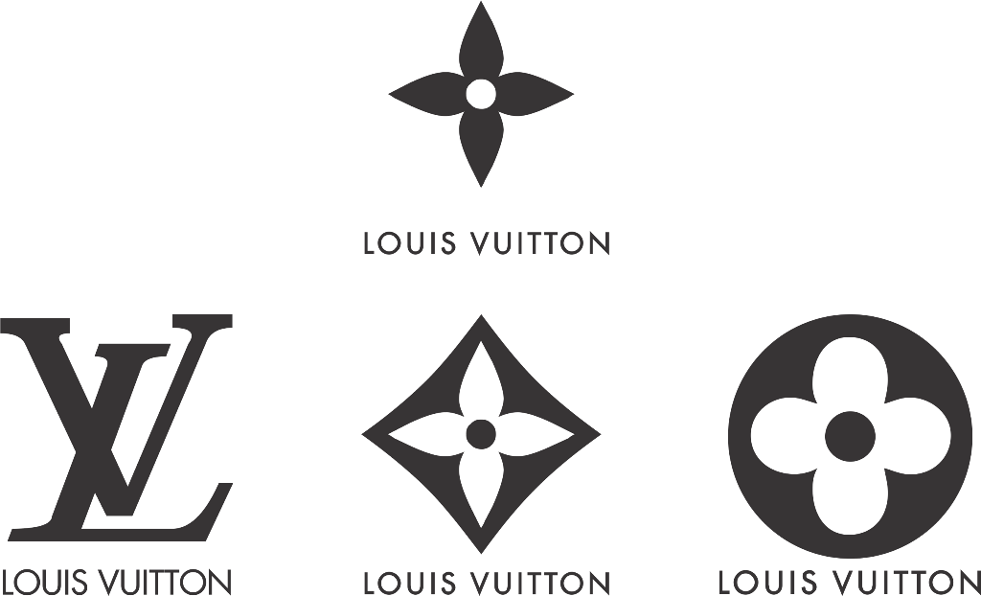
Above are some of Louis Vuitton’s different logos and brand symbols, often featured in their leather goods. This shows how they cater to different needs and different targets.
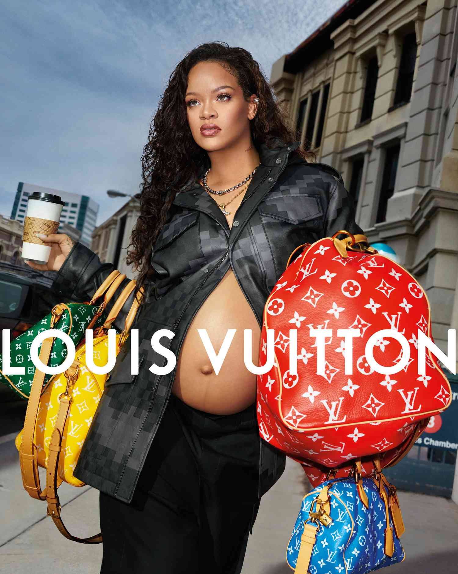
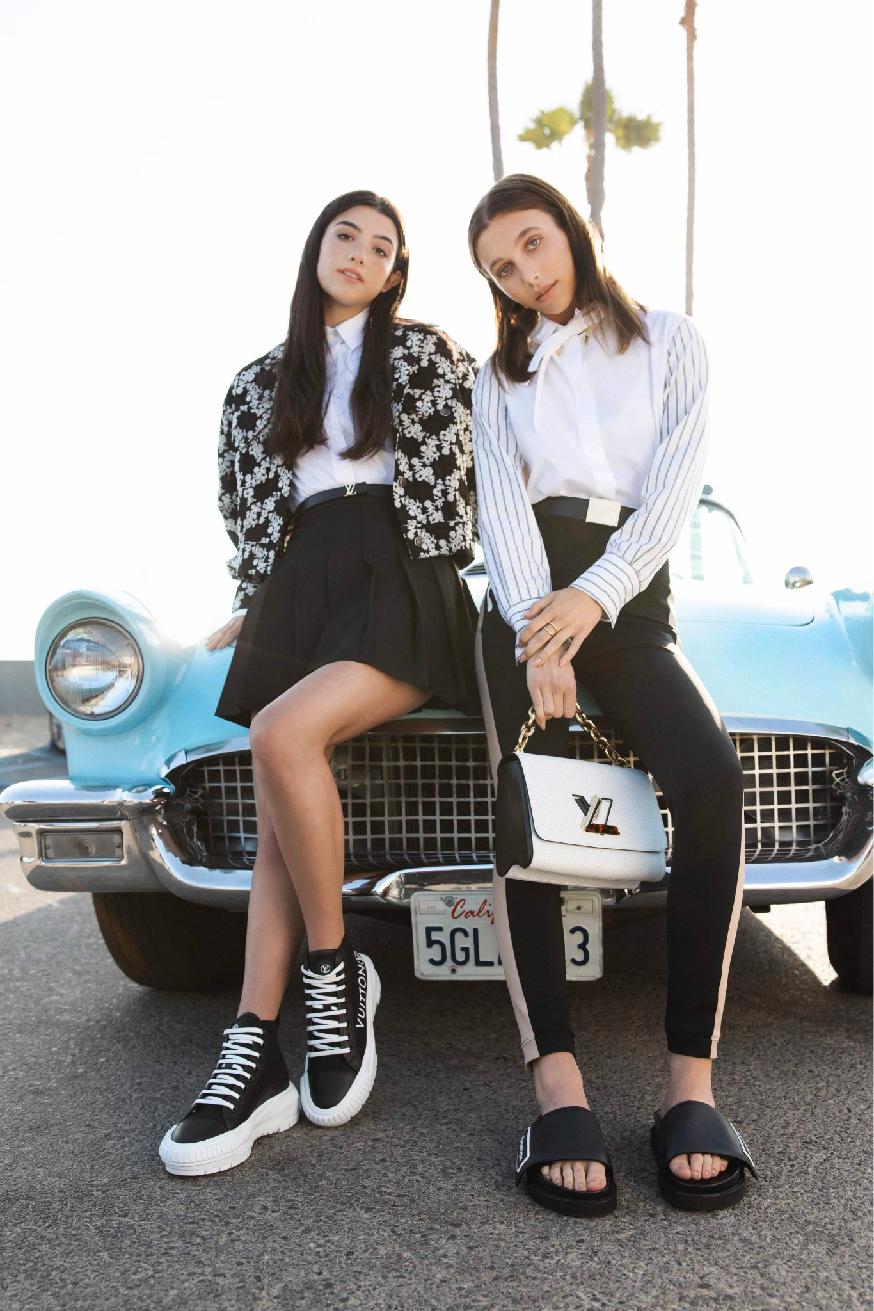
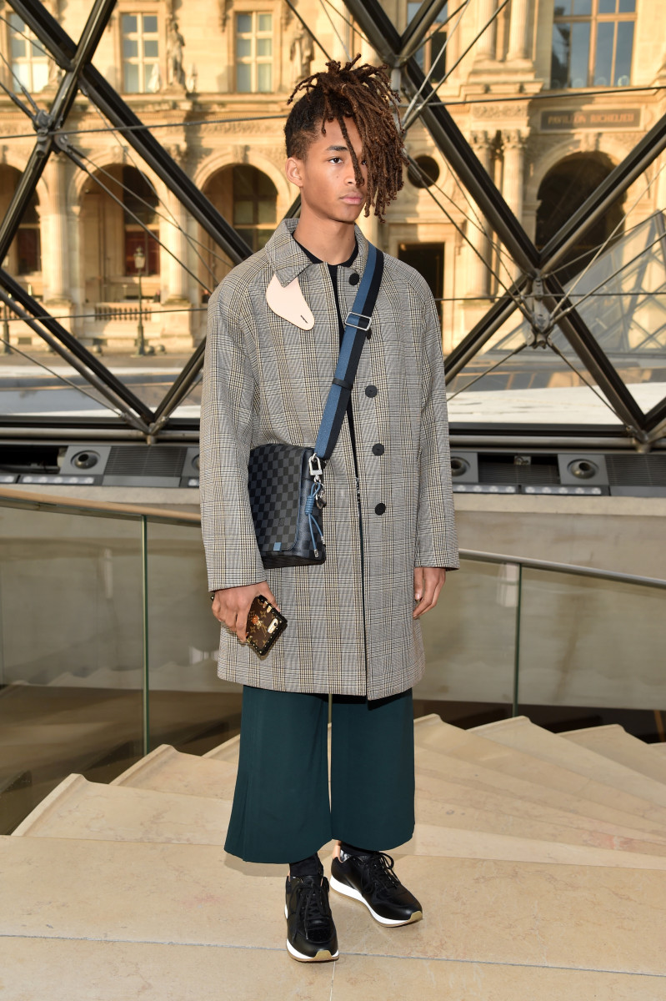
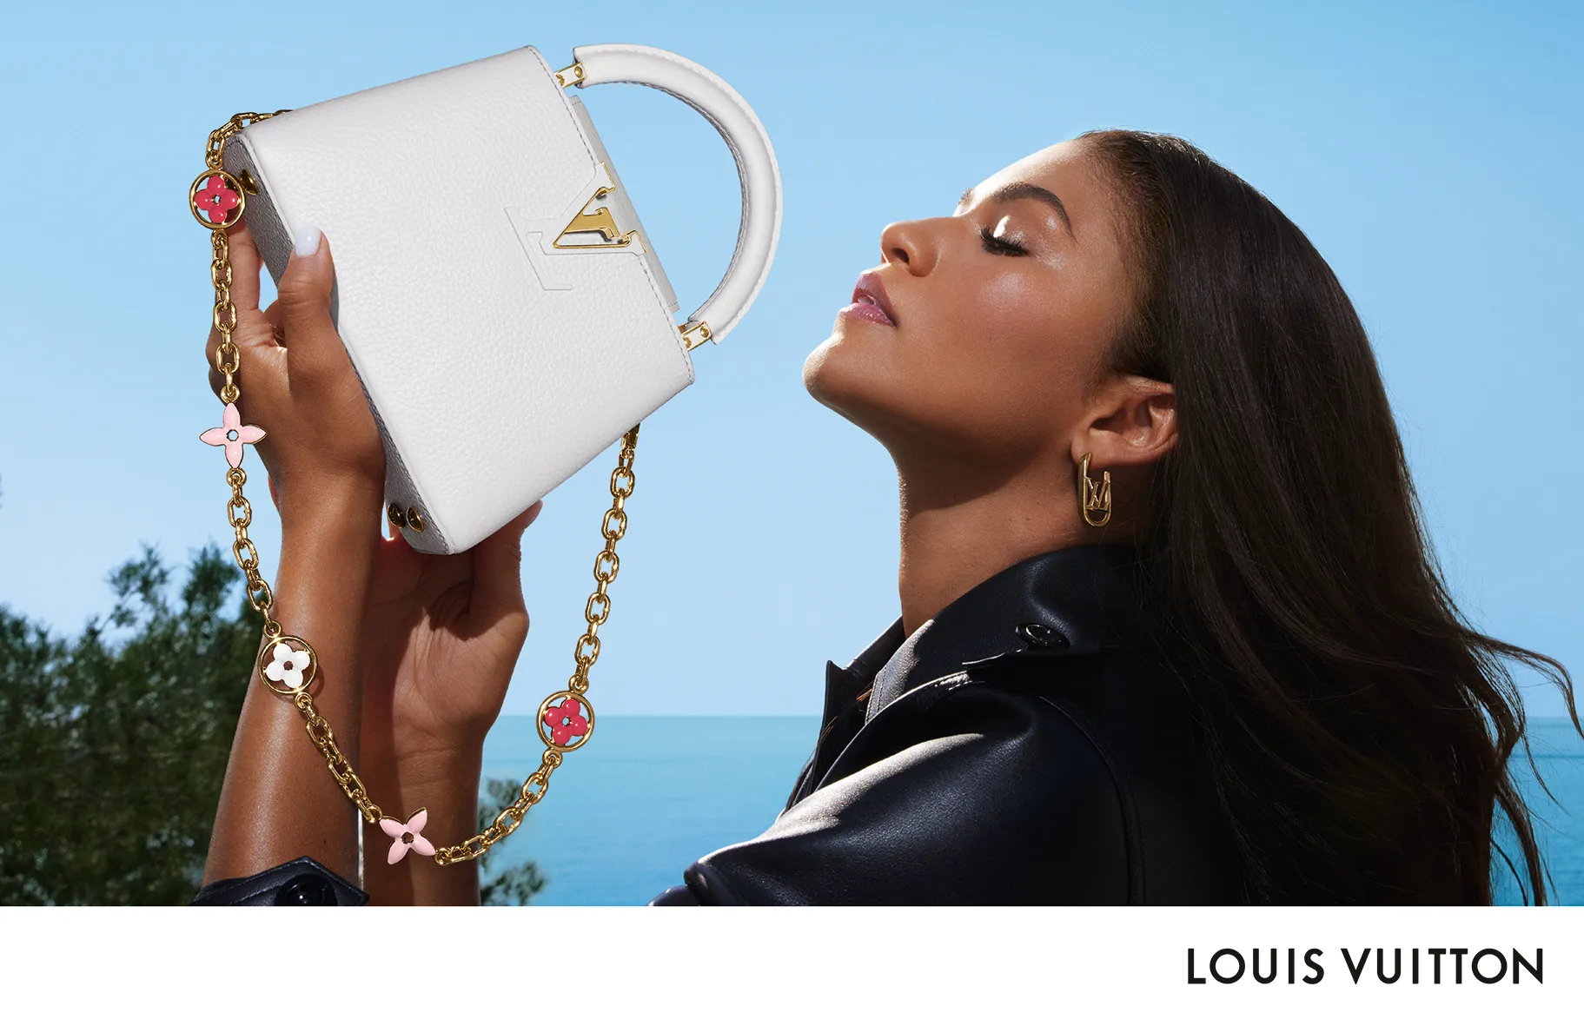
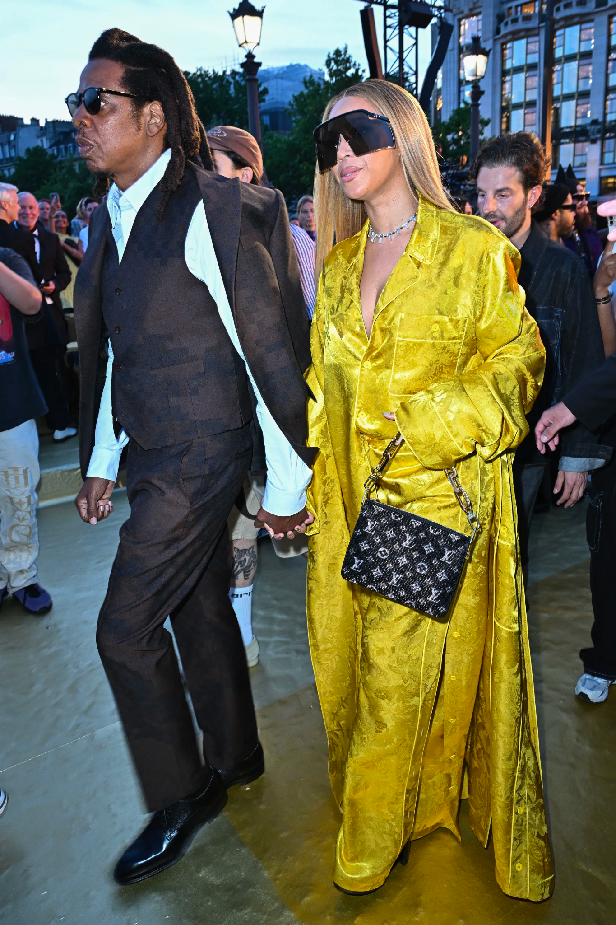



Works Cited
- “Handbags - US - May 2009.” Off Campus Access @ Baruch College, Chris Haak , May 2009, reports-mintel-com.remote.baruch.cuny.edu/display/461060/?fromSearch=%3Ffreetext%3Dlouis%2520vuitton%26resultPosition%3D30.
- Kongprasert, & Butdee, S. (2017). A methodology for leather goods design through the emotional design approach. Journal of Industrial and Production Engineering, 34(3), 170–179. https://doi.org/10.1080/21681015.2016.1240722
- “Luxury’s Got a Brand New Style .” Off Campus Access @ Baruch College, Unity Marketing Inc. , Apr. 2014, www-marketresearch-com.remote.baruch.cuny.edu/academic/Product/5405673.reports-mintel-com.remote.baruch.cuny.edu/display/1132681/?fromSearch=%3Ffreetext%3Dlouis%2520vuitton%26resultPosition%3D11.
- Mintel (Ed.). (n.d) Marketing to Middle and High Income Americans - US - 2022. Mintel Portal
- Mintel (Ed.). (n.d.). Teen Lifestyles - US - 2022. Mintel Portal . https://reports.mintel.com/display/1131769/?fromSearch=%3Ffreetext%3Dlouis%2520vuitton%26resultPo
- MRISimmons. (n.d.). MRISimmons . Off Campus Access @ Baruch College. https://insights-mrisimmons-com.remote.baruch.cuny.edu/university/baruch
- Vuitton, L. (2023, August 1). Louis Vuitton leather bags and accessories. Louis Vuitton Leather Bags and Accessories | LOUIS VUITTON ®. https://us.louisvuitton.com/eng-us/recommendations/louis-vuitton-leather-bags-and-wallets
- Wang, & Griskevicius, V. (2014). Conspicuous Consumption, Relationships, and Rivals: Women’s Luxury Products as Signals to Other Women. Journal of Consumer Research, 40(5), 834–854. https://doi.org/10.1086/673256

